Four Winns 225 Sundowner 2004, fantastic, versatile, fast boat in beautiful clean condition.

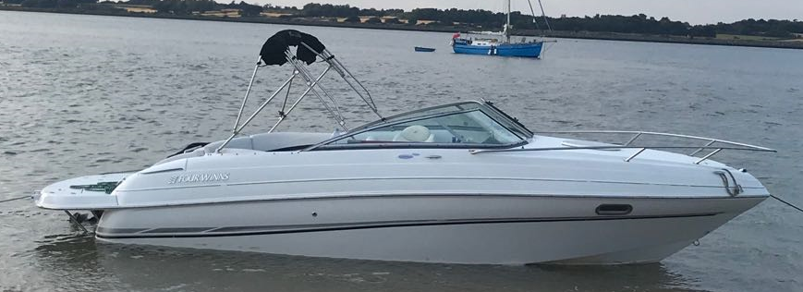
Volvo Penta 5.0 GXi with stainless duo prop, 270HP V8 engine. 2 berth cabin with pull out head. Lighting and stereo in the cabin with remote control at the helm. Cabin converts to double berth. Very well maintained, and includes a twin axle yard trailer, road trailer available by separate negotiation. Large anchor and chain / warp, lines and fenders included.
Crescent shaped seating with removable seat to walk through, large swim deck which really increases the versatility, big enough for 2 chairs to sit and watch the sunset after a day skiing, kneeboarding, wakeboarding, fishing or on the beach.
There is also a fabulous aft in fill cushion, making a huge sunpad for 2 people, and also a good size Four Winns removable table in Four Winns bag. Last serviced May 2018, little use last year. Very clean throughout, dry stored on trailer and never been antifouled. Full camper canvas cover with stand up head room to the aft which means that you can enjoy being on the water even on cooler / rainy days. Converts to bimini to keep the sun off on the hotter days. Carry on coolbox, load it up with your picnic and beers at home and lift straight onto the boat and away you go. Sink in the cockpit and shower after to wash down when you get out the water. I've owned this boat from 6 months old for the last 15 years because she is so much fun and so versatile, family have grown up with her, she's part of the family and sad to see her go. Also includes full cockpit cover. Absolutely ready to go and enjoy the summer, a really great looking clean boat that I'm sure any new owner will love.
Tel: Colin on 07584 550725
£15,500

